ASSIGNMENT

**NM ID**: 255FD73579C2E7EBC694D3BA566D02A7

**NAME:** SHARMIKA L

1. Website using WordPress:

**LINK:** <https://avenuefashiondotblog.wordpress.com>

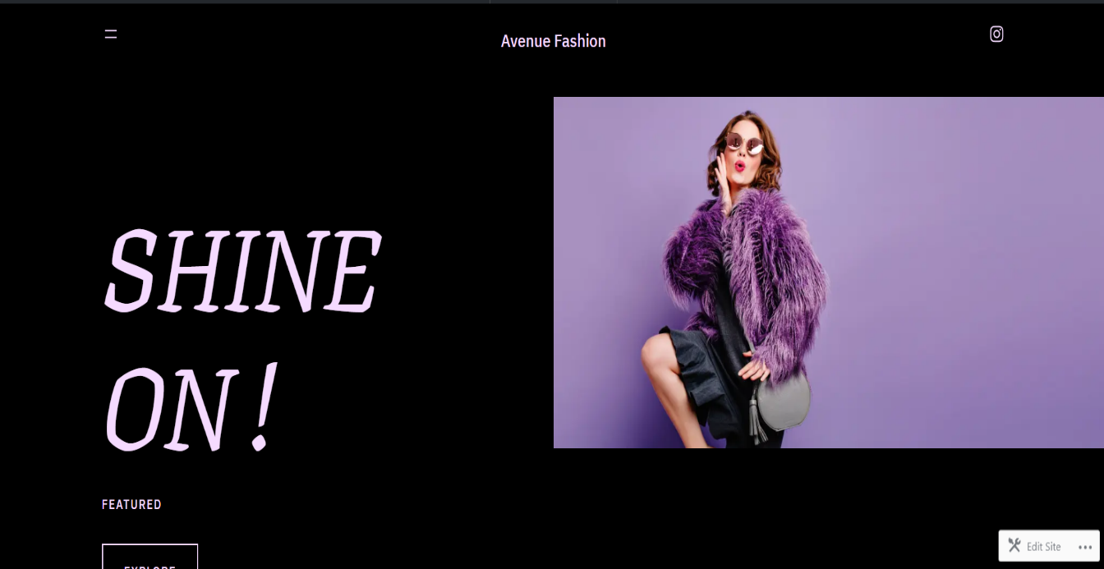

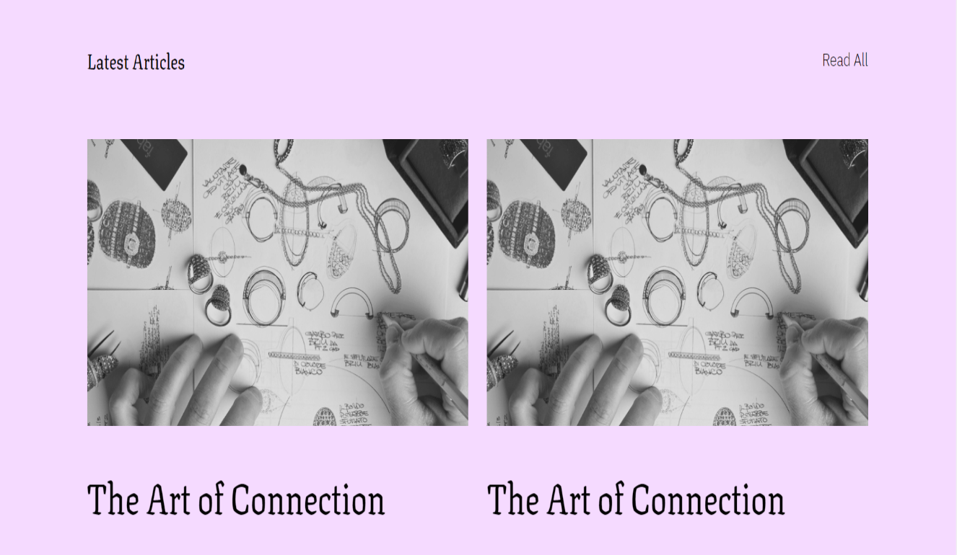

1. Create a new Facebook business page and post one social media poster for your brand.

**LINK:** [**https://www.facebook.com/profile.php?id=61552688333965**](https://www.facebook.com/profile.php?id=61552688333965)

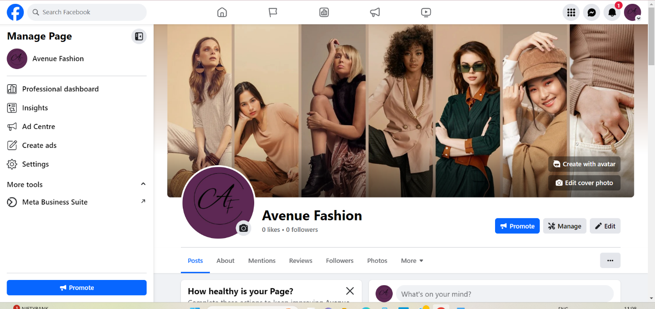

3.Create and design a social media advertisement poster using Canva.

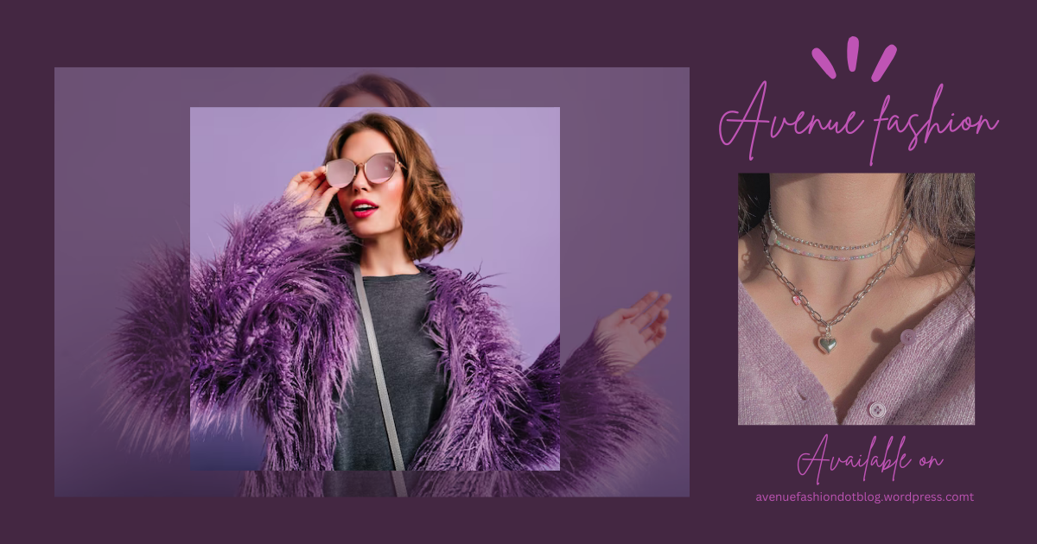

4. Create email newsletter design using MailChimp or Canva tool.

